# HIGH END 2018

## A world of exceptional sound: Sennheiser presents its portfolio for hi-fi aficionados

***Wedemark/Munich, April 26, 2018 –* At HIGH END 2018, which takes place at Munich’s MOC from May 10 to 13, Sennheiser will present selected audiophile headphones and amplifiers. A shining highlight are the new HD 820, which set a new benchmark in sound quality for closed-back headphones. Another model which is making audiophile hearts beat faster are the HD 660 S. They feature an open design and offer a natural, lifelike audio experience. At the pinnacle of Sennheiser’s portfolio are the HE 1: The world's best headphones are available for listening sessions at the Sennheiser booth.**

“Once again this year, we are looking forward to presenting our audiophile product portfolio at HIGH END in Munich”, said Axel Grell, Portfolio Management Audiophile at Sennheiser. “With the HD 820, we have a very special pair of headphones which, despite their closed design, offer exceptionally transparent sound. Visitors to HIGH END are kindly invited to experience this for themselves at our booth.”

**HD 820: audiophile sound, closed-back design**

Sennheiser presented the HD 820 to the public for the first time at CES in Las Vegas – and caused quite a stir: The circumaural dynamic stereo headphones deliver astonishingly transparent sound, shattering expectations of what was thought possible from a closed-back model and setting a new benchmark in sound quality for this type of design.

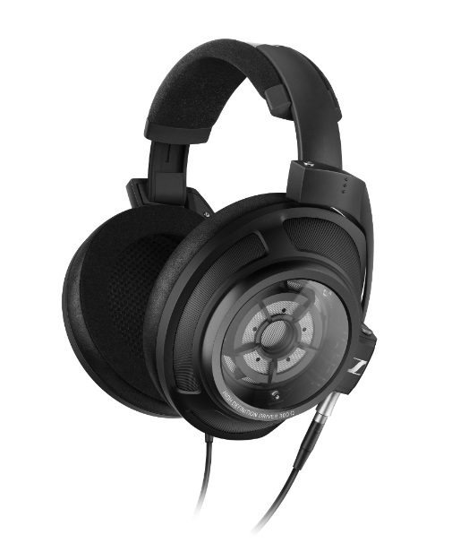

Sennheiser’s closed-back HD 820 headphones deliver astonishingly transparent sound.

Their incredibly realistic and natural sound field is achieved through the unique glass covers over the HD 820’s Ring Radiator transducers. Revealing the acoustics within, the curved Gorilla glass serves to reflect the sound waves from the rear of the transducer to two absorber chambers, resulting in minimal resonance. Manufactured in Germany using carefully selected components and materials, the headphones have been engineered to offer an unparalleled listening experience.

**HD 660 S: exceptional performance, great flexibility**

In the HD 660 S, leading-edge technology meets a long tradition of uncompromising audio and build quality. The headphones build on the legacy of the HD 650, surpassing the exceptional performance of their predecessor with a new and improved transducer design that delivers lower harmonic distortion for an even more natural, lifelike audio experience.

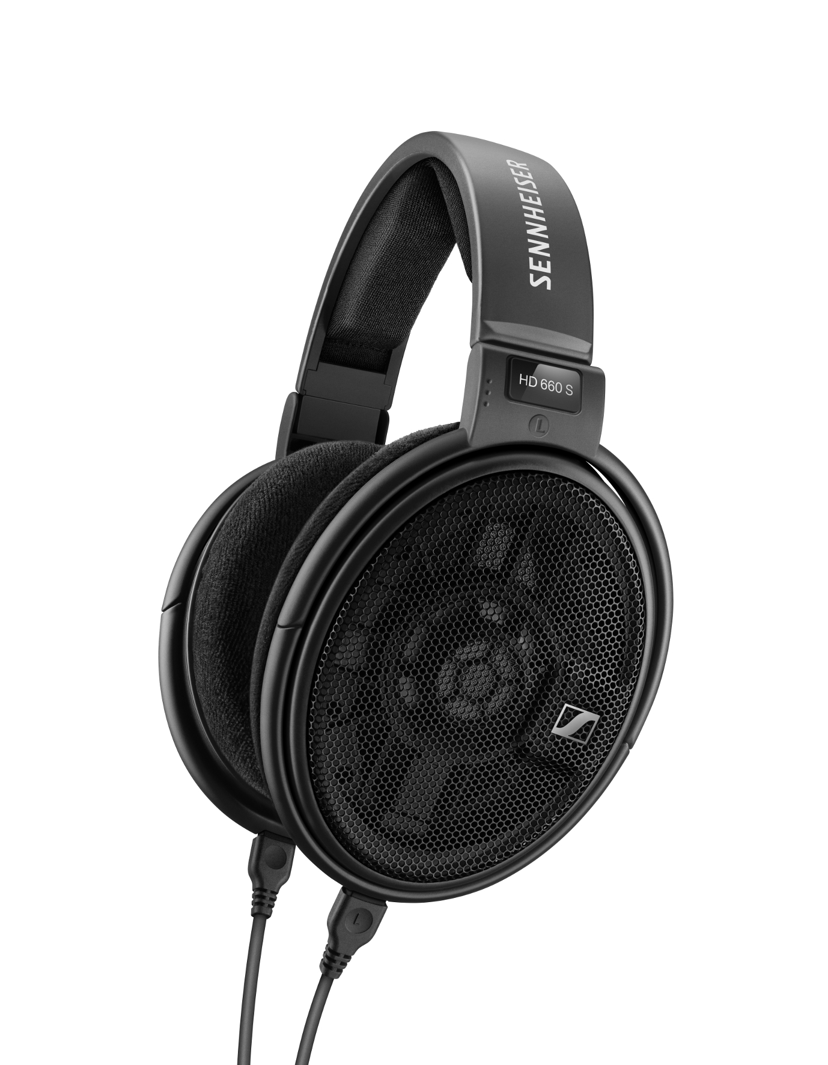

Building on the legacy of the HD 650, the HD 660 S deliver an even more natural, lifelike audio experience.

The HD 660 S perform well with a wide range of audio sources. The headphones’ lower impedance of 150 ohms allows them to be used with both HiRes mobile players or when directly connected to stationary HiFi components. To reveal their full acoustic potential, they are ideally connected to the balanced outputs of a dedicated headphone amplifier such as the Sennheiser HDV 820. The exceptional combination of HD 660 S and HDV 820 can also be experienced at HIGH END.

**HE 1: The best headphones in the world**

Like no other audio system, the HE 1 has redefined the limits of audiophile sound. With a frequency response of 8Hz to more than 100kHz, the headphones cover a range that extends far beyond the limits of human hearing. Even the slightest nuances and details of music become audible through the HE 1.

Offering incredible fidelity and detail, the HE 1’s total harmonic distortion is the lowest ever measured in a sound reproduction system. Visitors to the Sennheiser booth at HIGH END have the rare opportunity listen to the HE 1 – and to experience a new dimension of audiophile sound.

In addition to the HD 820, the HD 660 S and the HE 1, visitors to the trade show get to discover another stunning innovation at the Sennheiser booth: the AMBEO SMART HEADSET. The earpieces of the headset are equipped with high-quality microphones, allowing consumers to capture videos with immersive 3D sound on their iOS devices. Other products to be showcased at the booth include the IE 800 S ear-canal headphones and Sennheiser’s premium travel headphones, the PXC 550 Wireless.

Visit Sennheiser from May 10 to 13 in hall 1, booth B05at HIGH END in Munich.

**About Sennheiser**

Sennheiser is shaping the future of audio – a vision built on more than 70 years of innovation culture, which is deeply rooted within the family-owned company. Founded in 1945, Sennheiser is one of the world’s leading manufacturers of headphones, microphones and wireless transmission systems. With 20 sales subsidiaries and long-established trading partners, the company is active in more than 50 countries and operates its own production facilities in Germany, Ireland and the USA. Sennheiser has around 2,800 employees around the world that share a passion for audio excellence. Since 2013, Sennheiser has been managed by Daniel Sennheiser and Dr. Andreas Sennheiser, the third generation of the family to run the company. In 2016, the Sennheiser Group had sales totaling €658.4 million. [www.sennheiser.com](http://www.sennheiser.com)

**Global Press Contact**

Sennheiser electronic GmbH & Co. KG

Jacqueline Gusmag

Public Relations Manager Consumer Electronics

T: +49 (0)5130 600-1540

[jacqueline.gusmag@sennheiser.com](mailto:jacqueline.gusmag@sennheiser.com)